Cointegration and ECM: GBPUSD and USDCAD
Method 27 / Engle-Granger on log closes / one-lag ECM / Alpari D1 full available history

Study setup
Logical pair: PX=GBPUSD , PY=USDCAD
Broker symbols: GBPUSD_i , USDCAD_i
Snapshot: 2026-11-03_majors_alpari_D1
Timeframe: D1
Matched window: 1999-01-05 to 2026-11-02 (UTC bar dates)
Matched level count n: 7205
Dropped unfinished last bar dated 2026-11-03 UTC after a tick-volume check against the prior complete day.
ECM lags of deltas: 1
Complete matched rows (Excel): GBPUSD-USDCAD_Coint_D1.xlsx
Complete matched rows (HTML table): GBPUSD-USDCAD_Coint_D1_data.html

Method carried forward
Engle-Granger cointegration works on log price levels, not returns. For each unordered pair, PX is the left leg and PY the right leg. Step one: OLS ln(PY) = alpha + beta * ln(PX) + e. Step two: statsmodels Engle-Granger coint test on (ln(PY), ln(PX)). Error-correction: delta ln(PY)_t = c + kappa * e_{t-1} + lagged delta ln(PY) and delta ln(PX) (one lag each) + u_t. Headline is the Engle-Granger p-value (lower = stronger evidence of a stationary spread) with kappa and beta reported alongside. Same-sample Pearson r of log returns is a side check only. beta is not an automatic lot-size hedge. This is not a trading signal.

Results (headline)
alpha: 0.415302
beta: -0.462257
Engle-Granger t: -1.936497
Engle-Granger p: 0.561388
5% critical value: -3.336978
ECM kappa: -0.000949
kappa t-stat: -1.8798
ECM R^2: 0.001902
spread std: 0.119969
Pearson r (returns): -0.456462

Conclusion
Engle-Granger for PY=USDCAD on PX=GBPUSD: beta=-0.4623, alpha=0.4153, coint_t=-1.9365, p=0.5614 (5% crit=-3.3370). ECM kappa=-0.0009 (t=-1.88). Pearson r of returns = -0.4565. beta is not a lot-size hedge. Not a trading signal.

Charts
Daily closes

Engle-Granger residual spread
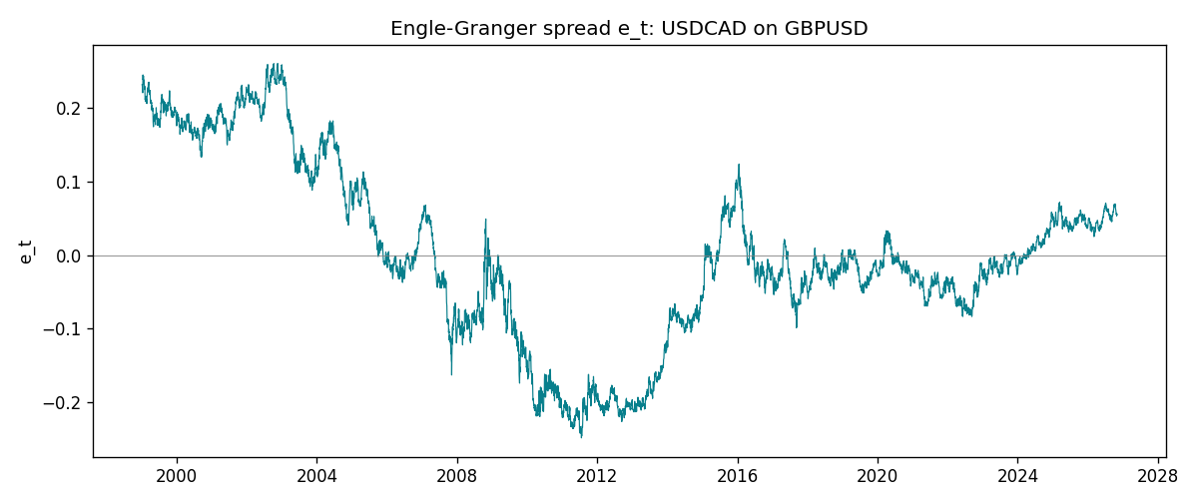
Daily log returns
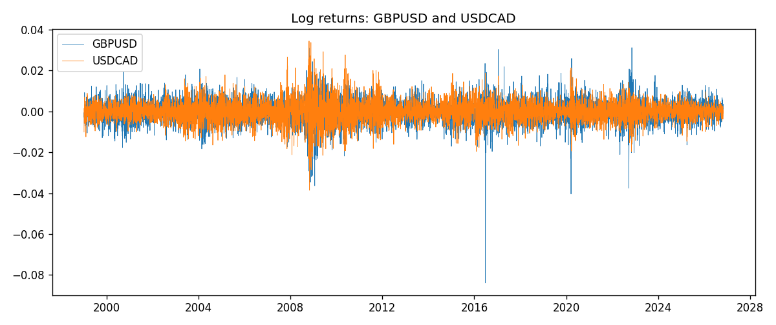

Data report
Matched rows are in the sibling Excel workbook named GBPUSD-USDCAD_Coint_D1.xlsx. Embedding all rows as a Word table is impractical; this file holds column summaries and the first and last 15 matched rows.
Column summaries
column | count | mean | std | min | 25% | 50% | 75% | max
GBPUSD_open | 7205 | 1.5161639 | 0.2182756 | 1.06854 | 1.32505 | 1.51142 | 1.63205 | 2.1066
USDCAD_open | 7205 | 1.2670469 | 0.16900802 | 0.9168 | 1.119 | 1.29857 | 1.3723 | 1.6183
GBPUSD_high | 7205 | 1.5224596 | 0.21884187 | 1.08366 | 1.32981 | 1.5182 | 1.6384 | 2.1161
USDCAD_high | 7205 | 1.2719479 | 0.16896591 | 0.9336 | 1.1234 | 1.30394 | 1.3769 | 1.619
GBPUSD_low | 7205 | 1.5098441 | 0.21750249 | 1.03518 | 1.31956 | 1.50336 | 1.62444 | 2.0983
USDCAD_low | 7205 | 1.2624879 | 0.16904619 | 0.9056 | 1.1144 | 1.29361 | 1.36793 | 1.6102
GBPUSD_close | 7205 | 1.5162333 | 0.21823062 | 1.06879 | 1.3252 | 1.5114 | 1.6322 | 2.1065
USDCAD_close | 7205 | 1.2670655 | 0.16898286 | 0.916 | 1.11851 | 1.29871 | 1.37253 | 1.6137
GBPUSD_tick_volume | 7205 | 94776.836 | 153518.92 | 62 | 9986 | 52867 | 91739 | 1273370
USDCAD_tick_volume | 7205 | 80835.261 | 147176.39 | 37 | 5509 | 40849 | 71515 | 1410818
GBPUSD_spread | 7205 | 26.978348 | 19.192834 | 0 | 11 | 20 | 50 | 50
USDCAD_spread | 7205 | 23.508952 | 18.282466 | 0 | 9 | 17 | 40 | 60
GBPUSD_real_volume | 7205 | 3.5541156e+09 | 8.441481e+10 | 0 | 0 | 0 | 0 | 2.4038164e+12
USDCAD_real_volume | 7205 | 1.8330194e+10 | 9.6578305e+10 | 0 | 0 | 0 | 0 | 2.5751613e+12
GBPUSD_log_price | 7205 | 0.40618063 | 0.14086036 | 0.06652717 | 0.28156339 | 0.41303637 | 0.4899288 | 0.7450278
USDCAD_log_price | 7205 | 0.22754214 | 0.13650023 | -0.08773891 | 0.11199744 | 0.26137146 | 0.31665575 | 0.47852968
GBPUSD_log_return | 7205 | -2.188e-05 | 0.00563988 | -0.08388241 | -0.00312535 | 3.221e-05 | 0.0031749 | 0.03112653
USDCAD_log_return | 7205 | -1.219e-05 | 0.00514402 | -0.03859748 | -0.00283601 | 4.92e-05 | 0.00272763 | 0.03436319
spread_e | 7205 | -0 | 0.11996886 | -0.24794926 | -0.06721125 | -0.01252015 | 0.06291494 | 0.25992516
ecm_fitted | 7204 | -1.079e-05 | 0.00022432 | -0.00176414 | -0.00015735 | -1.516e-05 | 0.0001252 | 0.00133274
First 15 matched rows (selected columns)
time | GBPUSD_log_price | USDCAD_log_price | spread_e | GBPUSD_log_return | USDCAD_log_return
1999-01-05 | 0.50361972 | 0.41363167 | 0.23113141 | -0.0028966287 | -0.010131666
1999-01-06 | 0.5030152 | 0.41330099 | 0.23052129 | -0.00060452184 | -0.0003306769
1999-01-07 | 0.50089649 | 0.4148212 | 0.23106211 | -0.002118709 | 0.0015202092
1999-01-08 | 0.49500107 | 0.41277168 | 0.22628739 | -0.0058954193 | -0.0020495197
1999-01-11 | 0.48931594 | 0.40925791 | 0.22014562 | -0.0056851331 | -0.0035137769
1999-01-12 | 0.49158164 | 0.41587738 | 0.22781243 | 0.0022657001 | 0.0066194721
1999-01-13 | 0.50071468 | 0.4204194 | 0.23657626 | 0.0091330396 | 0.0045420214
1999-01-14 | 0.50265231 | 0.42735705 | 0.2444096 | 0.0019376331 | 0.0069376546
1999-01-15 | 0.50089649 | 0.42166649 | 0.23790739 | -0.0017558204 | -0.0056905671
1999-01-18 | 0.50210773 | 0.42264993 | 0.23945074 | 0.0012112405 | 0.00098344542
1999-01-19 | 0.50398226 | 0.42539845 | 0.24306577 | 0.0018745281 | 0.002748513
1999-01-20 | 0.49907688 | 0.41943376 | 0.23483353 | -0.0049053846 | -0.0059646885
1999-01-21 | 0.50222878 | 0.41515138 | 0.23200814 | 0.0031518998 | -0.0042823796
1999-01-22 | 0.50470694 | 0.41765715 | 0.23565946 | 0.0024781662 | 0.0025057712
1999-01-25 | 0.50591358 | 0.41851295 | 0.23707303 | 0.0012066366 | 0.00085579808
Last 15 matched rows (selected columns)
time | GBPUSD_log_price | USDCAD_log_price | spread_e | GBPUSD_log_return | USDCAD_log_return
2026-10-13 | 0.28166903 | 0.3516423 | 0.066543846 | 0.0036434319 | -0.0046395653
2026-10-14 | 0.27675256 | 0.35316078 | 0.06578965 | -0.0049164679 | 0.0015184751
2026-10-15 | 0.2833502 | 0.34955063 | 0.065229304 | 0.0065976411 | -0.0036101503
2026-10-16 | 0.28710941 | 0.34611842 | 0.063534815 | 0.0037592051 | -0.0034322068
2026-10-19 | 0.28535938 | 0.34423489 | 0.060842318 | -0.0017500314 | -0.0018835331
2026-10-20 | 0.29095172 | 0.34052829 | 0.059720816 | 0.0055923442 | -0.0037066008
2026-10-21 | 0.29219935 | 0.33968137 | 0.059450624 | 0.0012476328 | -0.00084691787
2026-10-22 | 0.29242331 | 0.33705064 | 0.056923425 | 0.00022396082 | -0.0026307268
2026-10-23 | 0.29030862 | 0.3370792 | 0.055974448 | -0.0021146949 | 2.85545e-05
2026-10-26 | 0.28787455 | 0.3371363 | 0.054906391 | -0.0024340661 | 5.7106554e-05
2026-10-27 | 0.28550971 | 0.33967425 | 0.056351174 | -0.0023648393 | 0.0025379458
2026-10-28 | 0.2870869 | 0.33583632 | 0.053242309 | 0.0015771808 | -0.0038379274
2026-10-29 | 0.29067509 | 0.33572196 | 0.05478661 | 0.0035881935 | -0.00011436495
2026-10-30 | 0.29202015 | 0.33469208 | 0.0543785 | 0.0013450605 | -0.0010298736
2026-11-02 | 0.29311727 | 0.33530727 | 0.055500844 | 0.0010971256 | 0.00061519094

